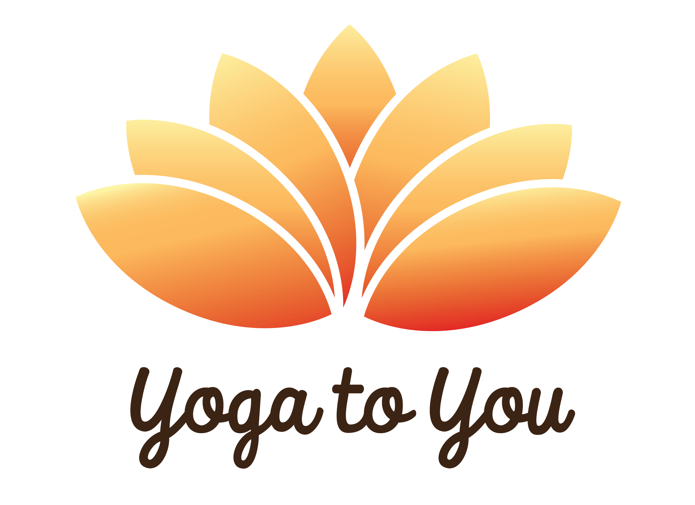

Yoga to You PDX
Cancellation and Refund Policy

Dearest yogi,

We hope that you understand that we are a small business and need to adhere to our cancellation policy regardless of events that may occur in your lives. Please take time to read the policy below.

For regular yoga class appointments booked at the Alameda Yoga Studio, the student may cancel and receive a full refund if they cancel before 24 hours prior to the appointment. If the student cancels within 24 hours of the appointment, they will not receive a refund of the class fees.

For special events, series, and workshops, the student may cancel and receive a full refund if they cancel before 24 hours prior to the appointment unless otherwise noted on the appointment. If the student cancels within 24 hours of the appointment, they will not receive a refund of the class fees.

Regarding the SUP Yoga Teacher Training, the registration deposit is non-refundable. Once the deposit payment is submitted, there are no refunds regardless of the reason offered by the participant. The full training cost is also non-refundable. Once the full payment is submitted and received, the registration fees are non-refundable regardless of reasons specified by the participant. The participant is welcome to email the company at info@yogatoyoupdx.com to submit their request for a refund with their specified reason or emergency, but the owner/company reserves the right to refuse any requests for refunds.

Please let us know if you have any questions or concerns about this policy by contacting us directly.

Yoga to You PDX
(503) 891-4819
info@yogatoyoupdx.com
yogatoyoupdx.com

